

Lab #4: Function Generator

ME 305-03

November 12, 2015

Carter Price

Sarah Visitacion

**Objective**

The objective of this lab was to create a function generator. The program accepts a digit from the keypad, which indicates which waveform to display (Sawtooth, sine or square). The program then prompts the user for a one-byte integer NINT, the number of interrupts per Basic Time Interval (BTI) to display the designated waveform.

**Tasks**

Task 1: Mastermind

Mastermind checks various flags in the program and branches accordingly. The states are as follows:

* State 0: init - Sets the prompt flag so the initial screen is displayed in the display task.
* State 1: Hub - Tests to see if SHOWflag is set to see if an error is displayed, if not, it tests if a key is pressed and branches according to which key is pressed (a digit, backspace or enter).
* State 2: Digit - State 2 tests if a waveform has been selected, if it has then it sets the digit flag and ensures that no more than 3 digits can be typed in for NINT.
* State 3: Backspace - State 3 occurs if backspace has been pressed, sets the BACKflag and ensures that it does not backspace beyond what is necessary.
* State 4: Enter - State 4 occurs if enter has been pressed, converts the ASCII values into BCD and sets the appropriate error flags to be displayed in the display task. If RESULT is an appropriate number, then it is set to NINT.
* State 5: Show error - State 5 occurs if the SHOWflag has been set and resets the prompt flags to return back to the Hub.

Task 2: Keypad Driver

Keypad driver tests to see if a key has been pressed. State 0 initializes the keypad, state 1 tests if a key is available and if so, stores it in TEMP, and State 2 tests if a key is in use, if it is not then another key can be accepted.

Task 3: Display

Display task is in charge of displaying the various prompts on the LCD. The states are as follows:

* State 0: Init - State 0 initializes the LCD screen
* State 1: Display Hub - State 1 tests the various flags and displays the prompt based on which flag is set.
* State 2: Initial Display - State 2 displays the initial prompt screen
* State 3: Sawtooth prompt - State 3 displays the sawtooth prompt screen
* State 4: Sine prompt - State 4 displays the sine prompt screen
* State 5: Square prompt - State 5 displays the square prompt screen
* State 6: Echo - State 6 takes what is entered on the keypad and displays it on the LCD
* State 7: Backspace - State 7 clears a digit on the LCD when backspace is pressed
* State 8: Too high - State 8 displays the ‘Magnitude too large’ error
* State 9: Zero magnitude - State 9 displays the ‘Zero magnitude inappropriate’ error
* State 10: No digits - State 10 displays the ‘No digits’ error

Task 4: Timer Channel 0

Task 4 initializes timer channel zero for the interrupt service routine and sets it up for an interrupt to occur every 0.1 msec.

Task 5: Function Generator

Task 5 displays the wave selected by the user. The states are as follows:

* State 0: init - State 0 sets NEWBTI
* State 1: wait for wave - State 1 checks to see if a wave has been selected
* State 2: new wave - Sets the Wave pointer with new variables
* State 3: wait for NINT - State 3 checks to see if the NINTOK flag is set and RUN is set so a wave can be displayed with the appropriate NINT
* State 4: display wave - State 4 updates the function generator to display the wave

**Inter-task Communication Variables**

|  |  |  |  |
| --- | --- | --- | --- |
| **Variable** | **Description** | **Set Location** | **Clear Location** |
| key_flag | indicates if a key is entered and in use | Task 2, state 1 | Task 1, throughout |
| BACKflag | indicates if the backspace key has been pressed | Task 1, state 1 hub | Task 1, state 3 |
| FIRSTCH | indicates if First character is being displayed | set upon initialization state 1; Task 3, done | Task 3, most states |
| sawprompt_flag | indicates saw wave prompt to be displayed | Task 1, state 2 | Task 3, state 3 |
| sineprompt_flag | indicates sine wave prompt to be displayed | Task 1, state 2 | Task 3, state 4 |
| squareprompt_flag | indicates square wave prompt to be displayed | Task 1, state 2 | Task 3, state 5 |
| wave | indicates if a wave has been selected | Task 1, state 2 | Task 3, multiple |
| DIGITflag | indicates a digit has been pressed and should be displayed | Task 1, state 2 | Task 3, state6 |
| TOOHIGHflag | indicates too high message should be displayed | Task 1, state 4 | Task 3, state 8 |
| ZEROflag | indicates zero mag message should be displayed | Task 1, state 4 | Task 3, state 9 |
| NODIGflag | indicates no digits message should be displayed | Task 1, state 4 | Task 3, state 10 |
| NINTOK | indicates that the NINT entered is valid | Task 1, state 4 | Task 5, state4 |
| RUN | indicates if Function gen should run | Task 1, state 4 | Task 1, state 2 |
| TEMP | stores the key entered in keypad | Task 2, state 1 | Task 1, multiple |

**Finite State Machines**

Task 1: Mastermind

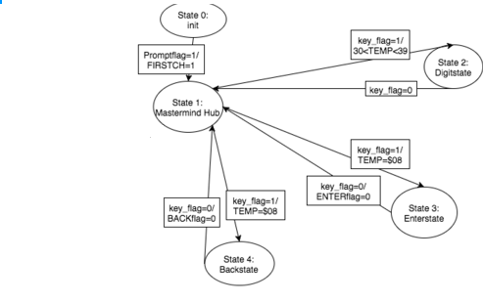

Task 2: Keypad Driver

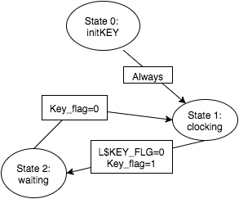

Task 3: Display

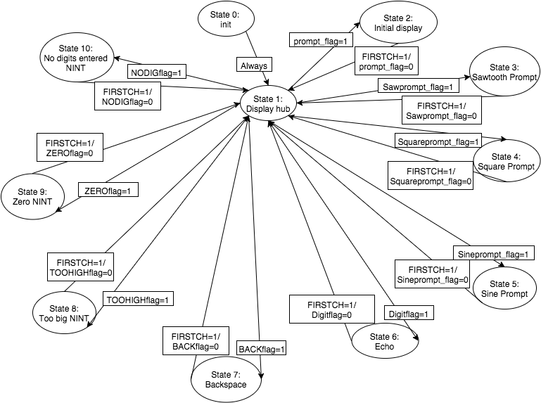

Task 4: Timer Channel 0

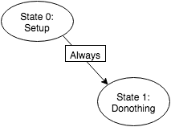

Task 5: Function Generator

